Mini Project Report On
“Farmer to Consumer Local Marketplace ”

Submitted by:
Prathmesh Deshmukh (RBT25CB044)
Om Akolkar (RBT25CB046)

Under the guidance of
Prof. Rutuja S. Bachhav
Course: DBMS

Academic Year: 2026–27 (Semester III)

Table of Contents

1. Abstract 5
2. Introduction 6
3. Literature Survey / Existing System 7
4. Proposed System 8
5. Methodology / Implementation 11
6. Results and Discussion 14
7. Conclusion and Future Scope 16
8. References 17
9. Appendix (Optional) 18

- Course Outcomes:
CO1: Design a database schema and 2 –tier application for a given problem statement.
CO2: Design SQL DDL/DML quries to create, secure, populate, maintain, and query a database using integrity constraint, stored function/procedure, cursor, trigger using PL/SQL block.
CO2: Design NO SQL query using mongoDB platform.

- PO Mapped
PO1: Engineering Knowledge: Apply knowledge of mathematics, natural science, computing,
engineering fundamentals and an engineering specialization as specified in WK1 to WK4 respectively to develop to the solution of complex engineering problems
PO2: Problem Analysis: Identify, formulate, review research literature and analyze complex engineering problems reaching substantiated conclusions with consideration for sustainable development.
PO3: Design/Development of Solutions: Design creative solutions for complex engineering problems and design/develop systems/components/processes to meet identified needs with consideration for the public health and safety, whole-life cost, net zero carbon, culture, society and environment as required.
PO4: Conduct Investigations of Complex Problems: Conduct investigations of complex engineering problems using research-based knowledge including design of experiments, modeling, analysis & interpretation of data to provide valid conclusions.
PO5: Engineering Tool Usage: Create, select and apply appropriate techniques, resources and modern engineering &amp; IT tools, including prediction and modeling recognizing their limitations to solve complex engineering problems.
PO8: Individual and Collaborative Team work: Function effectively as an individual, and as a member or leader in diverse/multi-disciplinary teams.
PO9: Communication: Communicate effectively and inclusively within the engineering community and society at large, such as being able to comprehend and write effective reports and design documentation, make effective presentations considering cultural, language, and learning differences
PO10: Project Management and Finance: Apply knowledge and understanding of engineering management principles and economic decision-making and apply these to one’s own work, as a member and leader in a team, and to manage projects and in multidisciplinary environments.
PO11: Life-Long Learning: Recognize the need for, and have the preparation and ability for i) independent and life-long learning ii) adaptability to new and emerging technologies and iii) critical thinking in the broadest context of technological change.

- PSO Mapped
PSO 1: Integrated Technical Proficiency: Ability to analyze, designs, and implement comprehensive software and business systems using modern tools and techniques, ensuring intelligent, efficient, and sustainable solutions.
PSO 2: Data-Driven Decision Making: Ability to apply mathematical and data analytics methods including algorithms, statisticalmodels, and data structures to solve complex computational and business problems and support innovation.
PSO 3: Interdisciplinary Collaboration &amp; Professionalism: Ability to effectively collaborate in multidisciplinary teams, integrating technical and business perspectives, and to communicate and manage projects with professional ethics and societal responsibility.
- SDG Goals Mapped
SDG 4: Quality Education: Develops students’ practical skills in database design, SQL, PL/SQL, NoSQL, and modern database technologies.
SDG 8: Decent Work and Economic Growth: Enhances students’ technical and problem-solving skills required for employment and professional development in the IT industry.
SDG 9: Industry, Innovation and Infrastructure: Promotes the development of technology-based database solutions using SQL, PL/SQL, and MongoDB.
SDG 12: Responsible Consumption and Production: Encourages efficient data management, storage, and utilization of computing resources.

- Abstract
Farmers in local areas often depend on middlemen to sell their produce, which lowers their earnings and gives consumers little information about where their food comes from. This mini project presents the Farmer to Consumer Local Marketplace, a database-driven web application that connects farmers directly with consumers. Farmers list products with a price per kilogram or per gram and manage their stock, while consumers browse the available produce, place orders, pay and track deliveries. An administrator manages users, orders, payments and deliveries.
The system follows a two-tier architecture: a MySQL database named farm_market designed from an ER diagram (Farmer, Products, Consumer, Orders, Order_Details, Payment and Delivery), and a Python Flask application that uses MySQL Connector with a plain HTML and CSS front end. Integrity constraints keep the data consistent, seven triggers automate stock updates, order totals, payment status and cancellations, and two cursor-based stored procedures produce the farmer sales report and the administrator summary. The result is a working three-portal system that demonstrates database design, CRUD operations, triggers and cursors.

- Introduction
  - Background / Motivation
In many towns and villages, farmers sell their produce through traders and commission agents. Each middleman adds a margin, so the farmer receives a smaller share of the price while the consumer pays more. Consumers also have no easy way to see which farmer grew the produce, how much stock is available, or what the price is per kilogram.
A local online marketplace can shorten this chain. If farmers can list their own products and prices, and consumers can order directly, both sides benefit. This project was chosen because it is a realistic problem that needs a well-designed relational database: users, products with units and stock, orders with line items, payments and deliveries.
  - Problem Definition
To design and implement a database-backed application in which farmers can add and remove products and set prices by quantity unit (kg or gram), consumers can order those products through a separate portal, and an administrator can supervise users, orders, payments and deliveries, while the database itself keeps stock, totals and order status consistent.
  - Objectives
- Design a normalised relational schema from the given ER diagram with proper primary keys, foreign keys and constraints.
- Provide three separate portals: Farmer, Consumer and Administrator.
- Implement basic CRUD operations for products, users, orders, payments and deliveries.
- Use triggers to keep stock, order totals and order status correct automatically.
- Use cursors in stored procedures to produce summary reports.
- Build a simple two-tier application (Flask and MySQL) with a plain HTML and CSS interface.

- Literature Survey / Existing System
  - Review of related tools or existing systems
Several kinds of systems already connect farmers, traders and buyers:
- Government and mandi platforms such as the National Agriculture Market (eNAM) support trading of agricultural commodities between registered traders and mandis. They are aimed mainly at bulk trade, not at individual households.
- Online grocery and agri-supply platforms such as BigBasket, DeHaat and similar services procure from farmers and sell to consumers or businesses, but the platform sets prices and sits between the farmer and the buyer.
- Informal methods such as weekly farmers' markets, roadside sales and WhatsApp groups let farmers sell locally, but they lack stock tracking, order records and payment history.
  - Gaps identified
- Small farmers have little control over price when a platform or middleman decides it.
- Informal selling has no automatic stock update, so products can be over-sold.
- Order, payment and delivery records are not kept in one consistent place.
- Many systems are large and complex; a small local marketplace needs a simple one with clear roles.

- Proposed System
  - System Overview
The Farmer to Consumer Local Marketplace has three portals that share one MySQL database. A farmer lists products with a price per unit (kg or g) and available stock. A consumer browses products, enters the quantity wanted, places an order, pays for it and can cancel it while it is still unpaid. The administrator monitors everything and creates deliveries for paid orders.
Business rules are enforced inside the database through constraints and triggers, so the data stays correct even if the application has a bug.
  - Features / Scope
- Farmer portal: register, add a product with unit and price, update price and stock, delete a product, view a sales report generated by a cursor procedure.
- Consumer portal: register, filter products by category, order several products at once, pay by UPI, card, net banking or cash on delivery, cancel an unpaid order, view order status and tracking details.
- Administrator portal: overview counts and revenue, farmer summary (cursor report), delete farmers, consumers and products, change order status, create, edit and delete deliveries, view payments and the product deletion log.
- Scope: a single-shop-style local marketplace running on one machine. Online payment gateways, product photos and live GPS tracking are outside the scope of this mini project.
  - System Architecture Diagram
The application uses a two-tier architecture. The browser shows plain HTML pages. The Flask application handles requests and talks to MySQL through MySQL Connector. All data, triggers and stored procedures live in the farm_market database.
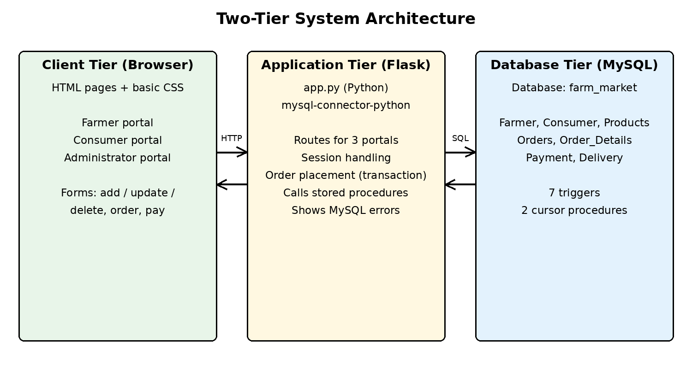
Figure 1: Two-tier system architecture
The ER diagram on which the database is based is shown below. Farmer lists many Products, a Consumer places many Orders, an Order contains weak-entity Order_Details lines (each linked to one Product), an Order is paid Through one Payment, and a Payment is related to Delivery records.
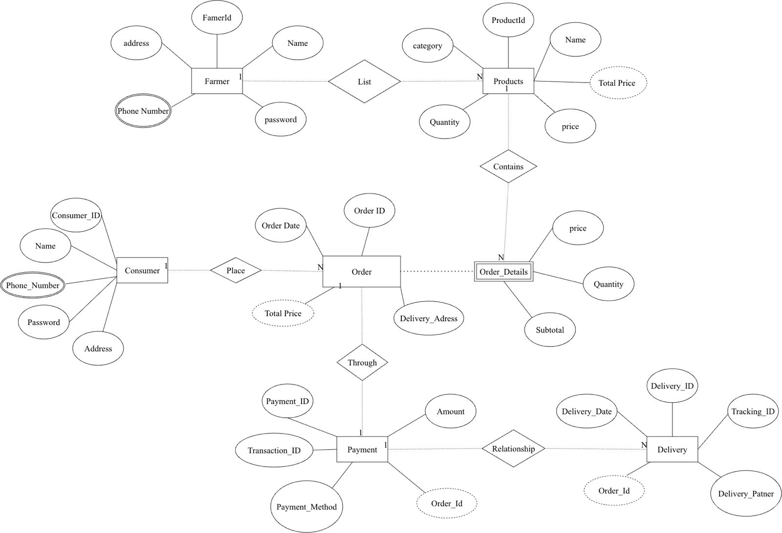
Figure 2: ER diagram of the marketplace

- Methodology / Implementation
  - Tools and Technologies Used
Component | Technology | Purpose
Database | MySQL 8 (MySQL Workbench) | Tables, constraints, triggers, stored procedures with cursors
Backend | Python 3 with Flask | Routes, sessions, business logic
Connector | mysql-connector-python | Connects Python to MySQL and calls stored procedures
Frontend | HTML and basic CSS | Pages and forms for the three portals (Jinja templates)
Platform | Windows, web browser | Development and testing

  - Modules Description
Database module. The file farm_market.sql creates the tables Farmer, Farmer_Phone, Consumer, Consumer_Phone, Products, Orders, Order_Details, Payment, Delivery and Product_Audit. Phone numbers are multivalued attributes, so they are stored in separate tables. Products.total_price is a generated column (price multiplied by quantity).
Table | Key columns | Relationship
Farmer | farmer_id (PK), name, address, password | 1 farmer lists N products
Products | product_id (PK), farmer_id (FK), name, category, unit (kg/g), price, quantity, total_price | Referenced by Order_Details
Consumer | consumer_id (PK), name, address, password | 1 consumer places N orders
Orders | order_id (PK), consumer_id (FK), order_date, delivery_address, total_price, status | 1 order has N order lines and 1 payment
Order_Details | (order_id, line_no) (PK), product_id (FK), quantity, price, subtotal | Weak entity of Orders
Payment | payment_id (PK), order_id (FK, unique), amount, payment_method, transaction_id | 1 payment has N deliveries
Delivery | delivery_id (PK), payment_id (FK), delivery_date, tracking_id, delivery_partner | Belongs to a payment

Farmer module. Lets a logged-in farmer insert, update and delete products and shows the sales report.
Consumer module. Lists products with available stock, creates orders and order lines inside one database transaction, records payments and cancels unpaid orders.
Administrator module. Reads data from all tables, deletes records, updates order status and creates deliveries. Admin access uses a fixed administrator username and password set in app.py.
  - Algorithms / Frameworks (if applicable)
Order placement algorithm.
- The consumer enters a quantity for one or more products and submits the form.
- The application inserts a row in Orders with status Placed.
- For each product with a quantity greater than zero, a row is inserted in Order_Details with the next line number.
- The trigger trg_od_before_insert checks the stock, copies the current price and calculates the subtotal. If stock is not enough it raises an error.
- The trigger trg_od_after_insert reduces the product stock and adds the subtotal to the order total.
- If every line succeeds the transaction is committed, otherwise it is rolled back and the error is shown.
Triggers. Seven triggers keep the data consistent:
Trigger | Event | Action
trg_od_before_insert | Before insert on Order_Details | Checks stock, copies price, computes subtotal
trg_od_after_insert | After insert on Order_Details | Reduces stock, updates order total
trg_orders_before_update | Before update on Orders | Allows cancelling only unpaid orders and returns stock
trg_payment_before_insert | Before insert on Payment | Allows payment only for Placed orders, sets amount from order
trg_payment_after_insert | After insert on Payment | Sets order status to Paid
trg_delivery_after_insert | After insert on Delivery | Sets order status to Shipped
trg_products_after_delete | After delete on Products | Writes the deleted product to Product_Audit

Cursors. Two stored procedures use explicit cursors. sp_farmer_sales_report loops over the products of one farmer and, for each, calculates the quantity sold and the revenue from non-cancelled orders. sp_admin_farmer_summary loops over all farmers and calculates how many products each has listed and the revenue earned. Both store results in a temporary table and return it to the application.
  - Screenshots or Outputs
Insert the following screenshots of the running application here (each about 6 inches wide):
- Figure 3: Home page showing the three portals
- Figure 4: Farmer portal with the product list and sales report
- Figure 5: Consumer portal showing available products and the order form
- Figure 6: My Orders page showing payment and cancel options
- Figure 7: Administrator portal showing overview, orders and deliveries

- Results and Discussion
  - Outputs achieved
- The database farm_market was created from a single SQL script with 10 tables, 7 triggers and 2 cursor procedures, and sample data for 2 farmers, 2 consumers and 6 products.
- The three portals work from one Flask application and one database.
- Stock reduces automatically when an order is placed and is returned when an unpaid order is cancelled.
- Order totals, payment status and shipping status update automatically through triggers.
- The sales report and the administrator summary are generated by cursor procedures.
The result of running SHOW TRIGGERS in MySQL Workbench is shown below; all seven triggers were created.
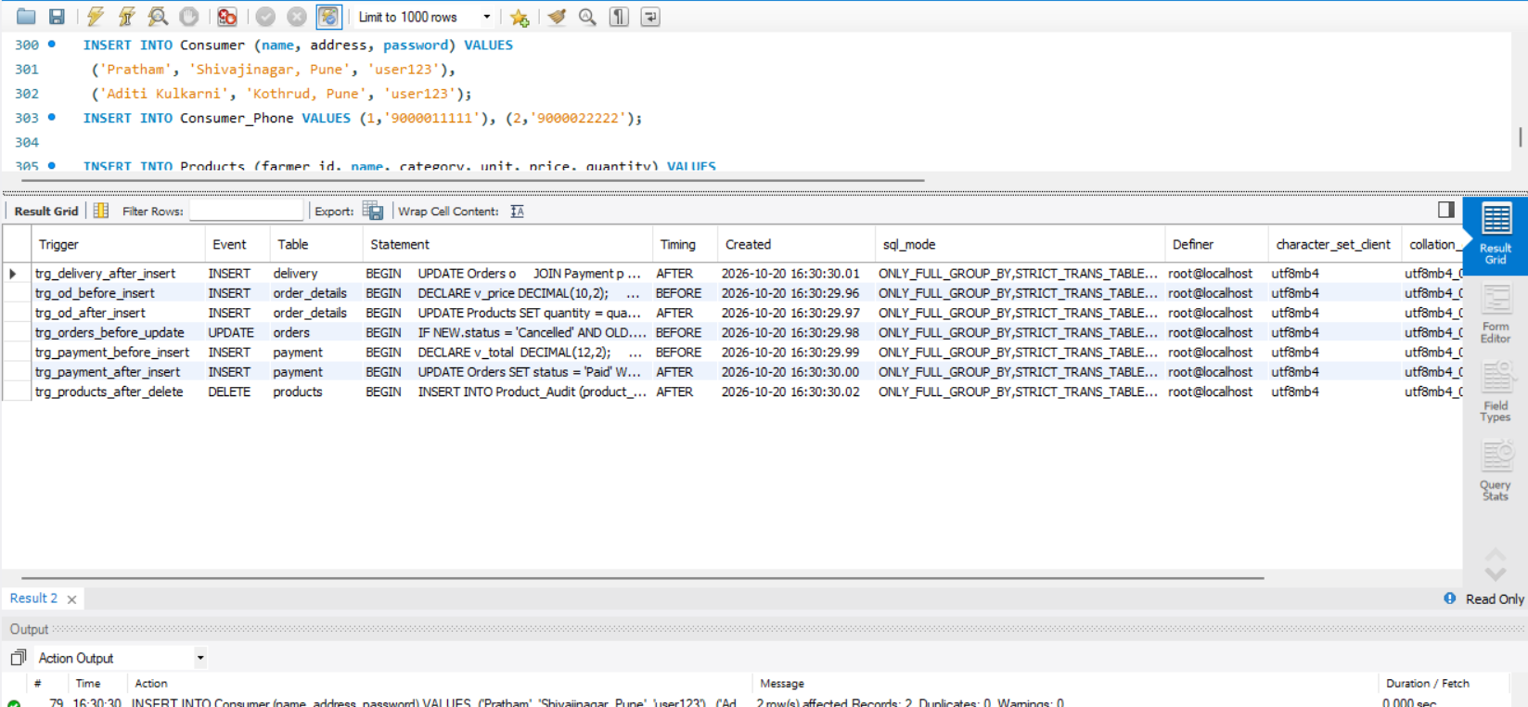
Figure 8: Triggers created in the farm_market database
The two stored procedures that use cursors were also created successfully.
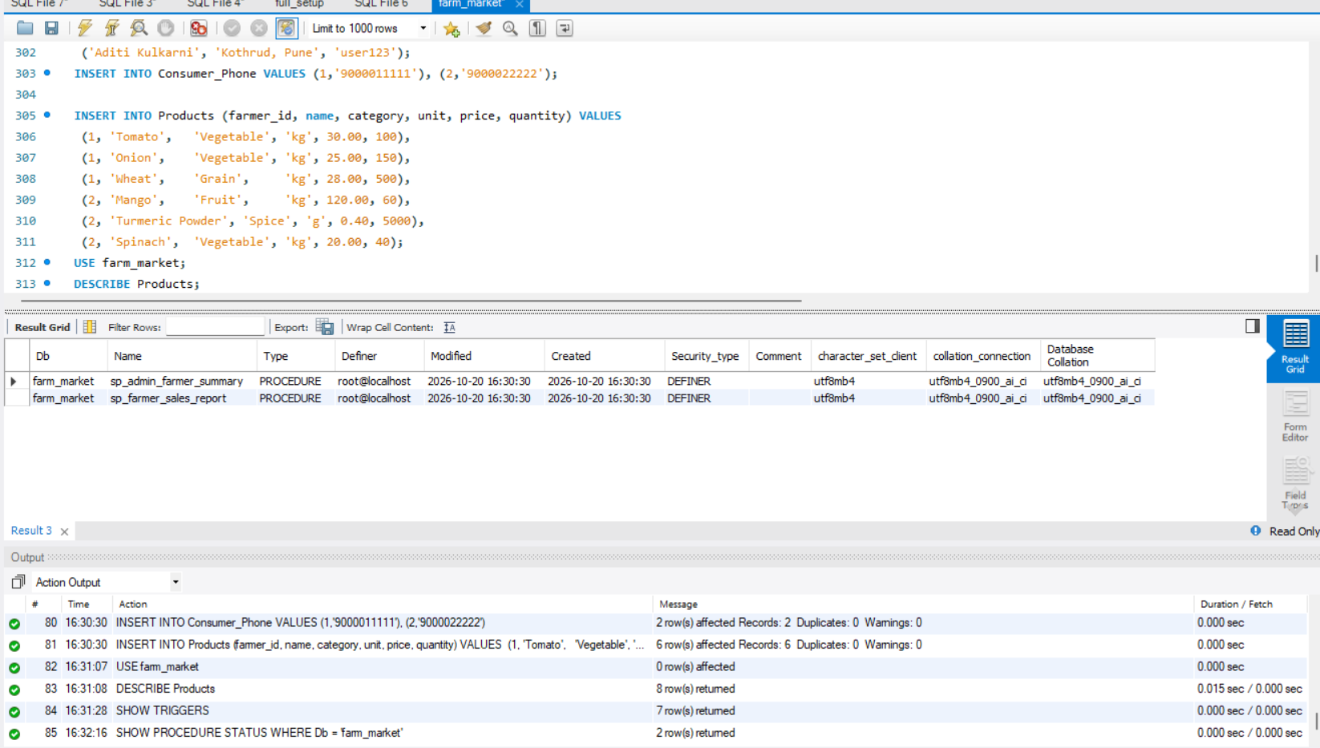
Figure 9: Cursor procedures created in the farm_market database
  - Performance / Accuracy (if measurable)
No formal benchmark was carried out because the project runs on a small sample data set on one machine. In normal use every page loads without noticeable delay. Accuracy of the data is ensured by the database: stock cannot become negative because the trigger rejects orders larger than the available stock, order totals are calculated by triggers rather than typed in, and a payment is accepted only once for an unpaid order.
  - Comparison with existing methods
Feature | Informal selling / middlemen | This system
Price control | Decided by trader | Set by the farmer per kg or gram
Stock tracking | Manual | Automatic through triggers
Order records | Not kept | Stored in Orders and Order_Details
Payment record | Cash, no record | Stored with transaction ID
Delivery tracking | None | Tracking ID and delivery partner
Reports | None | Cursor-based sales report and summary

- Conclusion and Future Scope
  - Summary of achievements
The project met its aim of building a farmer to consumer marketplace on a properly designed relational database. It covers schema design from an ER diagram, constraints, CRUD operations, triggers, cursors and a two-tier application with three portals. The database enforces the business rules, so the application stays simple.
  - Limitations and potential improvements
- Passwords are stored as plain text; they should be hashed before real use.
- Payments are only recorded. A real payment gateway such as UPI integration can be added.
- A farmer cannot delete a product that already appears in an order; the stock can be set to zero instead.
- Product photos, ratings and reviews, and search by location can be added.
- Live delivery tracking, SMS or email notifications and a mobile application are possible extensions.
- Indexes, backup and role-based database security can be added for larger deployments.

- References
[1] R. Elmasri and S. B. Navathe, Fundamentals of Database Systems, Pearson.
[2] A. Silberschatz, H. F. Korth and S. Sudarshan, Database System Concepts, McGraw-Hill.
[3] Oracle Corporation, MySQL 8.0 Reference Manual (triggers, stored procedures and cursors), https://dev.mysql.com/doc/.
[4] Oracle Corporation, MySQL Connector/Python Developer Guide, https://dev.mysql.com/doc/connector-python/en/.
[5] Pallets Projects, Flask Documentation, https://flask.palletsprojects.com/.
[6] National Agriculture Market (eNAM), Government of India, https://enam.gov.in/.
[7] Course material for DBMS, Department of Computer Science and Business Systems, JSPM's RSCOE, Pune.

- Appendix (Optional)
  - Source code snippets
Trigger that checks stock and calculates the subtotal (database/farm_market.sql):
CREATE TRIGGER trg_od_before_insert
BEFORE INSERT ON Order_Details FOR EACH ROW
BEGIN
DECLARE v_price DECIMAL(10,2);
DECLARE v_stock DECIMAL(10,2);
SELECT price, quantity INTO v_price, v_stock
FROM Products WHERE product_id = NEW.product_id;
IF NEW.quantity > v_stock THEN
SIGNAL SQLSTATE '45000'
SET MESSAGE_TEXT = 'Not enough stock available for a product';
END IF;
SET NEW.price = v_price;
SET NEW.subtotal = v_price * NEW.quantity;
END

Cursor procedure for the farmer sales report (outline):
CREATE PROCEDURE sp_farmer_sales_report(IN p_farmer_id INT)
BEGIN
DECLARE cur CURSOR FOR
SELECT product_id, name, unit FROM Products
WHERE farmer_id = p_farmer_id;
...
OPEN cur;
read_loop: LOOP
FETCH cur INTO v_id, v_name, v_unit;
IF done = 1 THEN LEAVE read_loop; END IF;
-- sum quantity and subtotal of non-cancelled orders
INSERT INTO tmp_report VALUES (...);
END LOOP;
CLOSE cur;
SELECT * FROM tmp_report ORDER BY revenue DESC;
END

Order placement in the Flask backend (backend/app.py):
cur.execute("INSERT INTO Orders (consumer_id, delivery_address) VALUES (%s,%s)",
(session["uid"], f["delivery_address"]))
oid = cur.lastrowid
for line_no, (pid, qty) in enumerate(items, start=1):
cur.execute("INSERT INTO Order_Details (order_id, line_no,"
" product_id, quantity) VALUES (%s,%s,%s,%s)",
(oid, line_no, pid, qty))
conn.commit()

  - Additional screenshots
Insert any additional screenshots here, for example the admin delivery form, the product deletion log, or MySQL Workbench table data.

